

# SUMMARY

Pelin Merve Kurt

**Citizenship:** Turkey **Birthday:** Date

 **Phone Number:** (+90) 5111111111

→ **Email address:** name@mail.com

✶ **Web Site:** Website

 **Address:** Address

As a product manager, I focus on product development by understanding and analyzing users' needs. One of my goals is to constantly improve products and offer easy use to users by prioritizing Customer Experience.

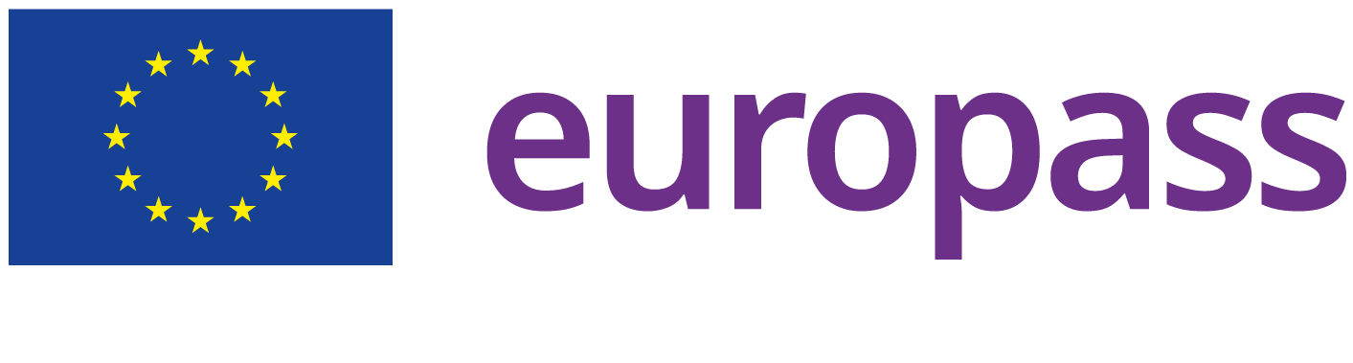

# EDUCATION AND TRAINING

**Master's Degree - Communication Arts and Design**

***Istanbul Technical University*** [2017-2021]

**City:** Istanbul

**Country:** Turkey

# Bachelor’s degree - Media and Communication Systems

***Istanbul Technical University*** [2021-2022]

**City:** Istanbul

**Country:** Turkey

# WORK EXPERIENCE

**Product Design Manager**

***Company Name*** [05/10/2016 – Current]

**City:** İstanbul

**Country:** Turkey

Explanation will come here.

# UX Designer

***Company Name*** [04/05/2015 – 02/10/2016]

**City:** Istanbul

**Country:** Turkey

Explanation will come here.

# DIGITAL SKILLS

Adobe / ﬁgma / Adobe Photoshop / Adobe illustrator / SketchApp / ProCreate

**Other Language:**

**English**

**Spanish**

# LANGUAGE

Mother Tongue: **Turkish**

**LISTENING** B1 **READING** B1 **SPEAKING** B1 **SPOKEN PRODUCTION** B2 **SPOKEN INTERACTION** A2 **WRITING** A2

**LISTENING** B2 **READING** C1 **SPEAKING** C1 **SPOKEN PRODUCTION** C1 **SPOKEN INTERACTION** C1 **WRITING** A2

Levels: A1 and A2: Basic user; B1 and B2: Independent user; C1 and C2: Master user